S.no | Topic | Subtopic (Project work included)
4 | React JS | 1)Getting Started with React  2)Setting up a React Project  3)JSX and Components  4) Webpack & Babel  5) React Components  6)Functional Components  7)Class Components  8)Props in React  9)State in React  10)Component LifeCycle Methods  11) React Router  12)Setting up React Router  13)Route Component  14)Link and NavLink Components  15)Context API  -> context  -> provider  -> consumer  16) Mini Project (ToDo List)  17) Hooks in React  18) Using useState Hook  19)Using useEffect Hook  20)Using useContext Hook  21) creating Custom Hooks  22)Redux Installation  23)Redux Core concepts  24)Redux Pure Functions  25)Redux Action  26)Redux Reducers  27)Redux Store  28)Redux Middleware  29)Introduction to Testing with Jest  30)Deployment of React App using Netlify

- Getting started with React JS - What is React JS
React is a powerful JavaScript library for building user interfaces, particularly for single-page applications (SPAs). It enables developers to create reusable components and manage application state efficiently.
It enables developers to design simple views for each state in their application, and React will efficiently update and render just the right components when the data changes.
React is not a framework (like Angular or Vue) — it focuses on the "View" in the MVC (Model-View-Controller) architecture.
React is maintained by Meta (formerly Facebook) and has a vast ecosystem of libraries and tools that support scalable front-end development.

Important Features of React:
- Virtual DOM: React uses a virtual DOM to efficiently update and render components, ensuring fast performance by minimizing direct DOM manipulations.
- Component-Based Architecture: React builds UI using reusable, isolated components, making code more modular, maintainable, and scalable.
- Hooks: React Hooks allow functional components to manage state and side effects, making them powerful and more flexible.
- Server-Side Rendering (SSR): React can be used for server-side rendering, where HTML content is generated on the server and sent to the client. This improves the app's performance, especially for SEO.
- React Router: React Router enables navigation in a React application. It allows you to define different routes for different views in a single-page application (SPA).
The latest stable version of React is v19 released on March 28, 2025. This version builds upon the major updates introduced in React v19.0.0.

1.1 Building blocks of React
The five main building blocks of React are :-
- Components: These are reusable blocks of code that return HTML.
- JSX: It stands for JavaScript and XML and allows you to write HTML in React.
- Props and State: props are like function parameters and State is similar to variables.
- Context: This allows data to be passed through components as props in a hierarchy.
- Virtual DOM: It is a lightweight copy of the actual DOM which makes DOM manipulation easier.

1.2 What is virtual DOM in React?
The virtual DOM in React is an in-memory representation of the actual DOM. It helps React efficiently update and render the user interface by comparing the current and previous virtual DOM states using a process called Diffing.
1.2.1 How Virtual DOM Works
- Efficient Rendering: The Virtual DOM is an in-memory representation of the actual DOM that React uses to optimize the process of updating and rendering UI changes.
- Diffing Algorithm: React compares the current and previous versions of the Virtual DOM using a diffing algorithm, identifying the minimal set of changes required to update the real DOM.
- Batch Updates: Instead of updating the real DOM immediately, React batches multiple changes to reduce unnecessary re-renders, improving performance.
- Faster Updates: Since updating the real DOM is slow, React minimizes direct DOM manipulations by only making updates where necessary after comparing the Virtual DOM.
- Declarative UI: With the Virtual DOM, React allows developers to write code in a declarative style, letting React handle when and how to efficiently update the UI.

  - Differentiate between Real DOM and virtual DOM?
REAL DOM VIRTUAL DOM
The actual DOM, a tree-like structure representing the UI elements. | A lightweight copy of the Real DOM used to optimize updates.
Slower as it requires direct updates to the actual DOM. | Faster because it minimizes direct manipulation of the Real DOM.
Directly manipulates the Real DOM, causing re-rendering of the entire UI. | Updates are made to the Virtual DOM first, then changes are batched and only the necessary changes are reflected in the Real DOM.
The entire UI might need to be re-rendered when changes occur. | Only the necessary components are re-rendered, reducing unnecessary re-renders.
Less efficient due to repeated direct updates to the Real DOM. | More efficient by minimizing direct DOM manipulation and batch updates.

1.4 How to write a comment in React?
There are two ways to write comments in React.
1. Multi-line comment: We can write multi-line comments in React using the asterisk format /* */.
/* :- This is a multi-line comment.
It can span multiple lines.
*/
2. Single line comment: We can write single comments in React using the double forward slash //.
// This is a single-line comment

1.5 React Ecosystem Overview
Library/Tool | Purpose
React DOM | Renders React components to the web
React Native | Build native apps using React syntax
React Router | Handles client-side routing
Redux, Zustand, Recoil | State management
Next.js | Framework built on top of React for SSR/SSG
React Testing Library, Jest | Unit testing for React components

2. Setting Up a React Project
To set up a React project, you need:
- Node.js installed.
- Familiarity with command-line interface (CLI).
- A code editor like Visual Studio Code.
You can check if Node.js and npm are installed by running the below commands in CLI.
node -v
npm -v
if node js is not installed then below are the steps to get node installed first.
Step 1: Install Node.js and npm
Node.js provides the runtime for running JavaScript outside the browser.
npm (Node Package Manager) is installed with Node.js and is used to manage JavaScript packages.
  - Go to the official Node.js website: https://nodejs.org
  - Download the LTS version (Recommended for stability)
- Example: Node.js LTS - 22.x.x
- This also installs npm automatically.
  - Run the installer
- Accept license agreements
- Click Next and finish installation
  - Verify the installation
Open a terminal or command prompt and run. You should see version
node -v
npm -v
Step 2: Create a New React App Using create-react-app
What is create-react-app?
A command-line tool provided by the React team that sets up a modern React project with no configuration.
- Navigate to the folder where you want your app:
cd path/to/your/projects
npx downloads the tool temporarily and runs it.
my-react-app is your project name.

- Create a new React app:
npx create-react-app my-react-app
Note: The above method is now deprecated, so use the below given method for creating the React application.
npm create vite@latest
- Navigate into your project folder:
cd my-react-app
- Start the development server:
npm start
- Opens the browser at http://localhost:3000
- Live reloads when you save any changes

2.1 Project breakdown structure:-
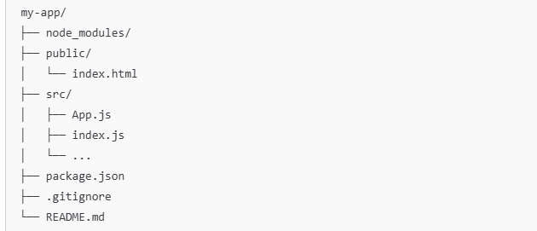
Folder/File | Purpose
public/ | Static files (like index.html)
src/ | JavaScript files & React components
App.js | Your main root component
index.js | Entry point where React app is rendered
package.json | Project metadata, dependencies
node_modules/ | Contains installed packages
.gitignore, README.md | Optional project files

2.2 What Happens in index.js?
import React from 'react';
import ReactDOM from 'react-dom/client';
import App from './App';

const root = ReactDOM.createRoot(document.getElementById('root'));
root.render(<App />);

React renders the App component into the root div in public/index.html
2.3 App.js
import React from "react";
import "./App.css";
function App() {
return <div className="App">Hello World !</div>;
}
export default App;

2.4 React Render method
React Render HTML to the web page by using a function called render(). The purpose of the function is to display the specified HTML code inside the specified HTML element. In the render() method, we can read props and state and return our JSX code to the root component of our app.

2.5 Browser JavaScript Engine Recap (Related to Babel)
Browser | JS Engine | Why Babel Helps
Chrome | V8 | Supports modern JS, but Babel ensures older fallback
Safari | JavaScriptCore (Nitro) | May lag behind latest ES features
Firefox | SpiderMonkey | Also benefits from transpiled JSX
Edge | V8 (Chromium) | Babel still useful for JSX and cross-compat

3. JSX in react & components
JSX is basically a syntax extension of regular JavaScript and is used to create React elements. These elements are then rendered to the React DOM. All the React components are written in JSX. To embed any JavaScript expression in a piece of code written in JSX we will have to wrap that expression in curly braces {}.

Why Use JSX?
- Looks like HTML but with the full power of JavaScript.
- Makes UI structures easy to understand and maintain.
- Enables dynamic rendering using JavaScript expressions.

Example of JSX: The name written in curly braces { } signifies JSX
const name = "Learner";
const element = (
<h1>
Hello,
{name}.Welcome to React JS Class
</h1>
);
3.1 JSX Rules You Must Know
Rule | Description
Only one parent element | Wrap multiple elements inside a single container (like <div>, <React.Fragment>, or <>)
Use className instead of class | Because class is a reserved keyword in JavaScript
Use camelCase for attributes | Example: onClick, tabIndex
Expressions in {} | You can embed any valid JavaScript expression inside {}

3.2 How do browsers read JSX?
In general, browsers are not capable of reading JSX and only can read pure JavaScript. The web browsers read JSX with the help of a transpiler. Transpilers are used to convert JSX into JavaScript. The transpiler used is called Babel.

3.3 JSX Examples & components
1. Embedding Variables:
const name = "Preenu";
const greeting = <h1>Hello, {name}!</h1>;

2. Conditional Rendering:
const isLoggedIn = true;
const message = <p>{isLoggedIn ? "Welcome Back!" : "Please Sign In"}</p>;
conditional rendering in React involves selectively rendering components based on specified conditions. By evaluating these conditions, developers can control which components are displayed, allowing for dynamic and responsive user interfaces in React applications.

3. Loops in JSX:
const items = ["Item 1", "Item 2", "Item 3"];
const list = (
<ul>
{items.map(item => <li key={item}>{item}</li>)}
</ul>
);

- JSX Fragments:
Used to group multiple elements without adding an extra DOM node.
when we are trying to render more than one root element we have to put the entire content inside the ‘div’ tag which is not loved by many developers. So since the React 16.2 version. Fragments were introduced, and we use them instead of the extraneous ‘div’ tag. The following syntax is used to create fragments in react.
<></> or <React.Fragment></React.Fragment>

Example:
return (
<>
<h1>Title</h1>
<p>Description</p>
</>
);

4. Webpack and Babel:-
4.1 Webpack
Webpack is a module bundler. It takes all your files (JavaScript, CSS, images, etc.), resolves their dependencies, and bundles them into one or more optimized files for the browser.
Think of it like packing your React project into a neat ZIP file for the browser to understand.

4.2 How Webpack Works in React
React Project Structure (example):
src/
App.jsx
index.js
styles.css
public/
index.html
You write:
import App from './App';
import './styles.css';
So Webpack:
- Follows these imports
- Transforms all files into a single main.js
- Injects it into index.html via <script src="main.js">

4.3 Babel:
Babel is a JavaScript compiler that converts modern JavaScript and JSX backward-compatible JavaScript so it runs in older browsers.
It’s like a translator that ensures your futuristic code works in today’s browsers.

4.4 Why Babel is Crucial in React?
Browsers do not understand JSX or newer ES6+ features like:

const greet = () => console.log("Hello");
const element = <h1>Hello JSX</h1>;

Babel compiles this into:
var greet = function () { console.log("Hello"); };
var element = React.createElement("h1", null, "Hello JSX");

4.5 Real-World Use Case
Use-Case: Team Building a SaaS Dashboard
- Dev A writes ES2022 + JSX
- Dev B uses Tailwind + SCSS
- Dev C adds dynamic imports for lazy-loading
Webpack + Babel:
- Makes sure all features are bundled, optimized, and backward-compatible
- Allows hot-reloading in dev, minification in prod
- Ensures everyone’s code works across Chrome, Firefox, Safari, etc.

4.6 Babel in a React Project (via Webpack)
Webpack uses babel-loader to process .js and .jsx files:
{
test: /\.(js|jsx)$/,
exclude: /node_modules/,
use: {
loader: "babel-loader",
options: {
presets: ["@babel/preset-env", "@babel/preset-react"]
}
}
}

4.7 How Webpack + Babel Work Together in React
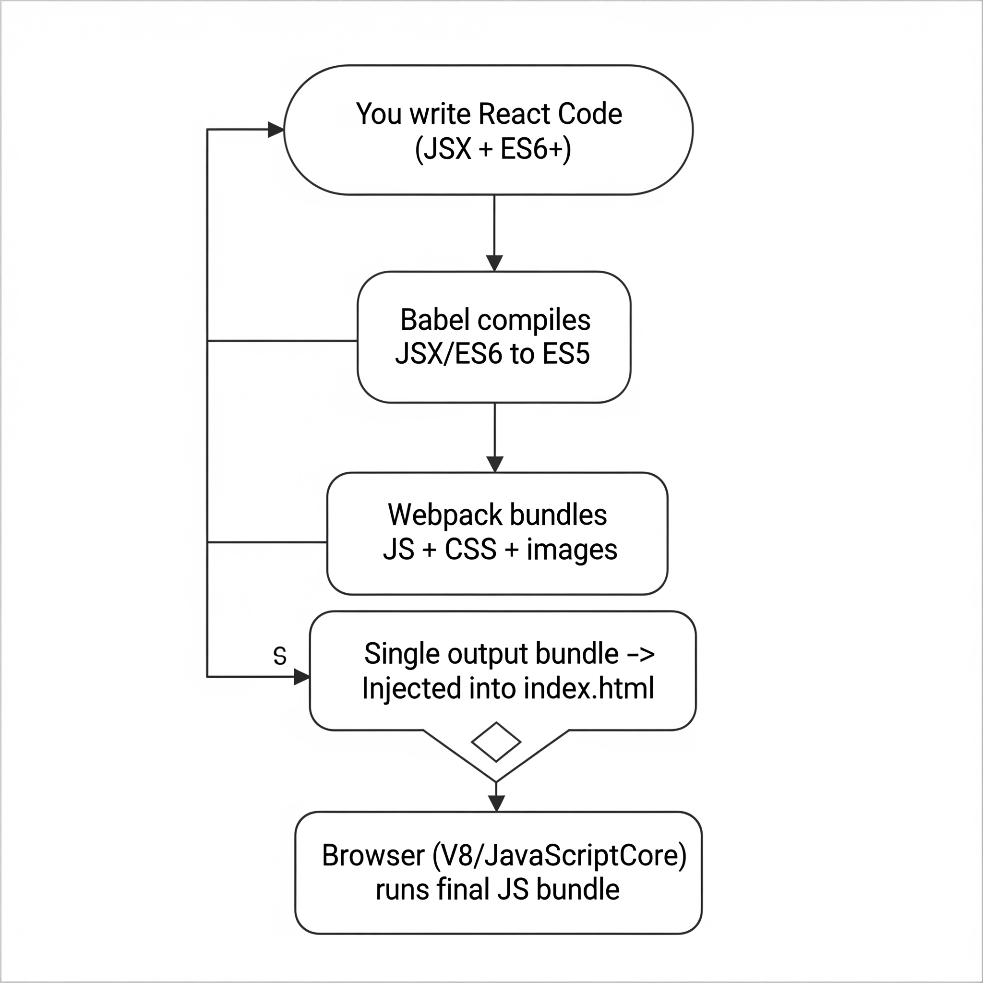
4.7 How It Works – Build Pipeline (Step-by-Step Flow)

Step | Description | Tool Used | Output
1 | You write React + JSX + modern ES6+ code in .jsx or .js files. | You | Raw source code
2 | Babel transpiles JSX & ES6+ into plain ES5 JavaScript. | Babel | Transpiled JavaScript
3 | Webpack bundles all transpiled code, CSS, and static assets into optimized output (bundle.js). | Webpack | Single or multiple output files
4 | Webpack Dev Server serves this bundle to the browser. | Webpack Dev Server | Live preview in browser
5 | Browser JS engine parses and executes the code. | Browser Engine | Running app in browser

Tool | Description | Why It's Needed in React | Real-world Analogy
Babel | JavaScript compiler that converts modern JS (ES6+) and JSX into older JS. | Browsers don’t understand JSX or latest JS features directly. | Language translator (e.g., English → Hindi)
Webpack | Bundler that compiles JS, CSS, images into optimized single/multiple files. | Manages & packages the entire app with dependency resolution. | Factory assembly line

5. React Components:-
A component is a building block that encapsulates a piece of the user interface (UI). It defines the structure and behavior of the UI, either by managing its own state or by receiving data through props and rendering content accordingly. Components are reusable and can be composed together to build complex UIs in a modular way.
- Components can be reused across different parts of the application to maintain consistency and reduce code duplication.
- Components manage how their output is rendered in the DOM based on their state and props.
- React loads only the necessary components, ensuring optimized performance.
- Only the specific Component updates instead of the whole page.
When creating a React component, the component's name MUST start with an uppercase letter.

5.1 Types of Components in React
Component Type | Description | Syntax Used | When to Use
Functional Component | Simple function that returns JSX | function / arrow | Most common in modern React
Class Component | ES6 class extending React.Component to manage state/lifecycle | class | For legacy or advanced use cases
Pure Component | Optimized class component with shallow prop/state comparison | PureComponent | For performance-sensitive components
Higher Order Component (HOC) | Function that takes a component and returns an enhanced one | function(HOC) | Reusability of logic (e.g. auth)
Controlled/Uncontrolled Component | Inputs where React controls value (or not) | form input pattern | In form management
Presentational vs Container | UI-only vs logic/state-handling components | project architecture | For design pattern structuring

5.2 Why Use Components?
- Break UI into smaller pieces
- Reuse code across the app
- Encapsulate logic and state
- Make testing and debugging easier
- Improve readability and maintainability

6. Functional Components

Functional Components are simpler and preferred for most use cases. They are javascript functions that return React elements. With the introduction of React Hooks, functional components can also manage state and lifecycle events.
- Stateless or Stateful: Can manage state using React Hooks.
- Simpler Syntax: Ideal for small and reusable components.
- Performance: Generally faster since they don’t require a 'this' keyword.

Practical:-
App.js
import React from "react";
function Student() {

return <h1>Hello React JS</h1>;
Functional component created using function keyword
}
export default Student;
OR
const Student = () => {

Functional component created using Arrow function
return <h1>Hello React JS</h1>;
};
export default Student;

Index.js
Let’s render the above created component in our main file.
import React from "react";
import ReactDOM from "react-dom";
import Student from "./Student";
ReactDOM.render(<Student name="React JS"/>,
Student component rendered with name as an prop
document.getElementById("root"));

7. Class Component:-
Class components are ES6 classes that extend React.Component. They include additional features like state management and lifecycle methods.
- State Management: State is managed using the this.state property.
- Lifecycle Methods: Includes methods like componentDidMount, componentDidUpdate, etc.
7.1 Practical:-
Inside src folder create a file named as App.js
import React, { Component } from "react";
Keyword
Component Name
class App extends Component {
render() {
return (
<h1> Hello Students </h1>
);
}
}
export default App;

7.2 Rendering the above created component
Now your React application has a component called App, which returns an <h1> element.
To use this component in your application, use similar syntax as normal HTML: <App />
So in main file i.e., index.js
import React from "react";
import ReactDOM from "react-dom";
Composing component
import App from "./App";
ReactDOM.render(<App />, document.getElementById("root"));

7.3 Difference Between Functional and Class Components
Functional Components:
- Defined as JavaScript functions.
- Use hooks for state and lifecycle management.
- Simpler syntax, better for performance due to no overhead from this.
Class Components:
- Defined as ES6 classes.
- Use this.state and this.setState for managing state.
- Lifecycle methods like componentDidMount are class-specific.

Conversion Example:
// Class Component
class Counter extends React.Component {
state = { count: 0 };
increment = () => {
this.setState({ count: this.state.count + 1 });
};
render() {
return (
<div>
<p>Count: {this.state.count}</p>
<button onClick={this.increment}>Increment</button>
</div>
);
}
}
// Functional Component
import React, { useState } from "react";
function Counter() {
const [count, setCount] = useState(0);
const increment = () => setCount(count + 1);
return (
<div>
<p>Count: {count}</p>
<button onClick={increment}>Increment</button>
</div>
);
}

8. Props
Components can be passed as props, which stands for properties.Props are like function arguments, and you send them into the component as attributes.
Props (short for Properties) are read-only inputs passed from a parent component to a child component.They allow you to customize components and reuse them by passing different values.
  - Practical using functional component:
Student.js
// Student.js (Child Component)
function Student(props) {
return <h1>Hello, {props.name}</h1>;
}
export default Student;
App.js
// App.js (Parent Component)
import Student from './Student';
function App() {
return (
<div>
<Student name="John" />
<Student name="Emma" />
</div>
);
}
export default App;
  - Practical using class component:
Student.js
import React, { Component } from "react";
class Student extends Component {
render() {
return (
<div>
<h1> Hello {this.props.name}</h1>
<h1> Your {this.props.sallary} </h1>
</div>
);
}
}
export default Student;

index.js
import React from "react";
import ReactDOM from "react-dom";
import Student from "./Student";
ReactDOM.render(<Student name="React JS" sallary="23000"/>, document.getElementById("root"));

  - Why Props Are Important in React
Use Case | Example
Pass data to children | Name, email, ID, etc.
Customize UI | Different text/images in each card
Event handling callbacks | onClick, onSubmit, etc.
Component composition | Card, Modal, Button reuse

  - Child props:
In React, "children" props (often written as props.children) refer to the content nested inside a component's opening and closing tags. used to make components more flexible and reusable
Useful when you want to inject HTML or components inside a wrapper/container.
Practical:- Student.js – Child Component
import React from "react";
const Student = (props) => {
return (
<h1>
Hello {props.children}
</h1>
);
};
export default Student;

index.js – Entry Point (Parent Component)
import React from "react";
import ReactDOM from "react-dom";
import Student from "./Student";
ReactDOM.render(
<Student>React is Js Library</Student>,
document.getElementById("root")
);

Explanation
Part | Description
<Student>...</Student> | Anything between opening and closing tag becomes the children prop
props.children | Special prop to access nested content
Hello {props.children} | Dynamically renders passed content
Reusable & Flexible | You can inject text, JSX, or components into props.children

  - propTypeChecking
PropTypes is a built-in library in React (via prop-types package) that allows you to specify the data types of props a component should receive.

Benefit | Description
Type Safety | Prevent bugs by ensuring correct prop types
Documentation | Serves as live documentation of expected props
Development Warnings | React gives warning in the console if type mismatches
Optional vs Required Props | Easily specify if a prop is required

Practical:-
Steps to Use PropTypes
1️. install the PropTypes package:
npm install prop-types

2️. Import and Apply in Your Component:
import PropTypes from 'prop-types';

function Greeting(props) {
return <h1>Hello, {props.name}!</h1>;
}
// Type Checking
Greeting.propTypes = {
name: PropTypes.string.isRequired,
};
// Greeting.defaultProps
export default Greeting;

Other Common PropTypes:
Prop Type | Description
PropTypes.string | A string
PropTypes.number | A number
PropTypes.bool | A boolean
PropTypes.func | A function
PropTypes.array | An array
PropTypes.object | An object
PropTypes.node | Anything renderable (JSX/text)
PropTypes.element | A single React element
PropTypes.shape() | An object with specific shape

Example with Shape
Greeting.propTypes = {
user: PropTypes.shape({
name: PropTypes.string,
age: PropTypes.number
}).isRequired
};

9. React States
In React, the state refers to an object that holds information about a component's current situation. This information can change over time, typically as a result of user actions or data fetching, and when state changes, React re-renders the component to reflect the updated UI.
Whenever state changes, React re-renders the component to reflect the updated data. This enables you to build dynamic UIs that respond to user interactions.

State is similar to props but it is private and fully controlled by the component. We can create a state only in the class component.

If we want to create a state in functional components then we need to use Hooks.
Syntax:
const [state, setState] = useState(initialState);
- state: The current state value.
- setState: A function that is used to update the state.
- initialState: The initial value that the state will hold when the component is first rendered.
Note: useState is a React Hook introduced in React 16.8 and must be used in functional components only.

9.1 Key Features of State in React
- Encapsulation of Data: Each React component has its own state, and the state data is encapsulated within the component. This means that state is not shared across components unless explicitly passed via props.
- Reactivity and Re-rendering: When state changes, React automatically triggers a re- of the component to reflect the updated state in the UI. React ensures that only the parts of the UI that depend on the state are re-rendered, improving performance.
- Mutable Within the Component: State is mutable, meaning you can change it using the setState Method (in class components) or the state-updating function returned by useState(in functional components). However, you should not directly mutate the state (e.g., this.state.count = 5), as this can lead to unexpected behavior.

9.2 Best Practices for Managing State in React
- Do Not Directly Modify State: Avoid directly modifying the state. Instead, use setState() or the state-updating function from useState() to ensure proper reactivity.
- Use Functional Updates for Previous State: If the new state depends on the previous state, use a functional update to avoid potential issues with state changes.
- Lift State Up When Necessary: In React, state should be lifted up to the nearest common ancestor if two components need to share the same state. This makes it easier to manage state at a higher level and pass it down via props.
- Use Multiple State Variables: You don’t have to store all your state in a single object. React allows you to use multiple useState() calls in a single component. This can improve readability and maintainability by keeping state values grouped logically.

9.3 State vs Props
While both state and props store data in React, they serve different purposes:
- State: Managed within the component, mutable, and used to store dynamic data that changes over time.
- Props: Passed from a parent component to a child component, immutable, and used to share data between components.
Note:- State can change over time and cause re-renders, whereas props are used to pass data from one component to another but are not directly modified by the component receiving them.

9.4 When to Use State in React
You should use state in React whenever:
- You need to store dynamic data that changes over time.
- The component should re-render when the state changes, reflecting updates in the UI.
- You need to manage user input, form data, or API responses.
However, if the data does not change over time, it should be handled via props instead of state.

Practical 1: creating state inside Class component’s
Student.js
import React, { Component } from "react";
class Student extends Component {
state = {
name :"React",
Technology : this.props.js
};
render() {
return (<h1> Hello {this.state.name} your Course is
{this.state.Technology}</h1>
);
}
}
export default Student;

index.js
import React from "react";
import ReactDOM from "react-dom";
import {createRoot} from 'react-dom/client';
import Student from "./Student";

const root=createRoot(document.getElementById("root"));
ReactDOM.render(<Student />, document.getElementById("root"));

Practical 2: changing props using state inside Class component’s

Student.js
import React, { Component } from "react";
class Student extends Component {
state = {
name :"React",
Technology : this.props.tech
};
render() {
return (<h1> Hello {this.state.name} your Course is
{this.state.Technology}</h1>
);
}
}
export default Student;

index.js
import React,{StrictMode} from "react";
import ReactDOM from "react-dom";
import {createRoot} from 'react-dom/client';
import Student from "./Student";

ReactDOM.render(<Student Technology="Full-Stack"/>, document.getElementById("root"));

Practical 3:- Creating State in Functional Component
Student.js
import React,{useState} from "react";
function Student(){
const [count,setCount]= useState(0);
const valueIncrement = () => {
setCount(count+1);
};
return (
<React.Fragment>
<h1>count the value : {count}</h1>
<button type="button" onClick={valueIncrement}>increment</button>
</React.Fragment>
)
}
export default Student;
index.js
import React from "react";
import ReactDOM from "react-dom";
import Student from "./Student";

ReactDOM.render(<Student/>, document.getElementById("root"));

10. Component LifeCycle-Methods
In React, the lifecycle refers to the various stages a component goes through. These stages allow developers to run specific code at key moments, such as when the component is created, updated, or removed. By understanding the React lifecycle, you can better manage resources, side effects, and performance.

Note:- Lifecycle applies only to Class Components, but similar behavior is achieved in Functional Components via Hooks (useEffect, etc.)

10.1 Three main phases of the React component lifecycle
- Mounting: Initializes, renders, and mounts the component (componentDidMount()).
- Updating: Handles state/prop changes, re-renders, and updates (componentDidUpdate()).
- Unmounting: Cleans up before removal (componentWillUnmount()).
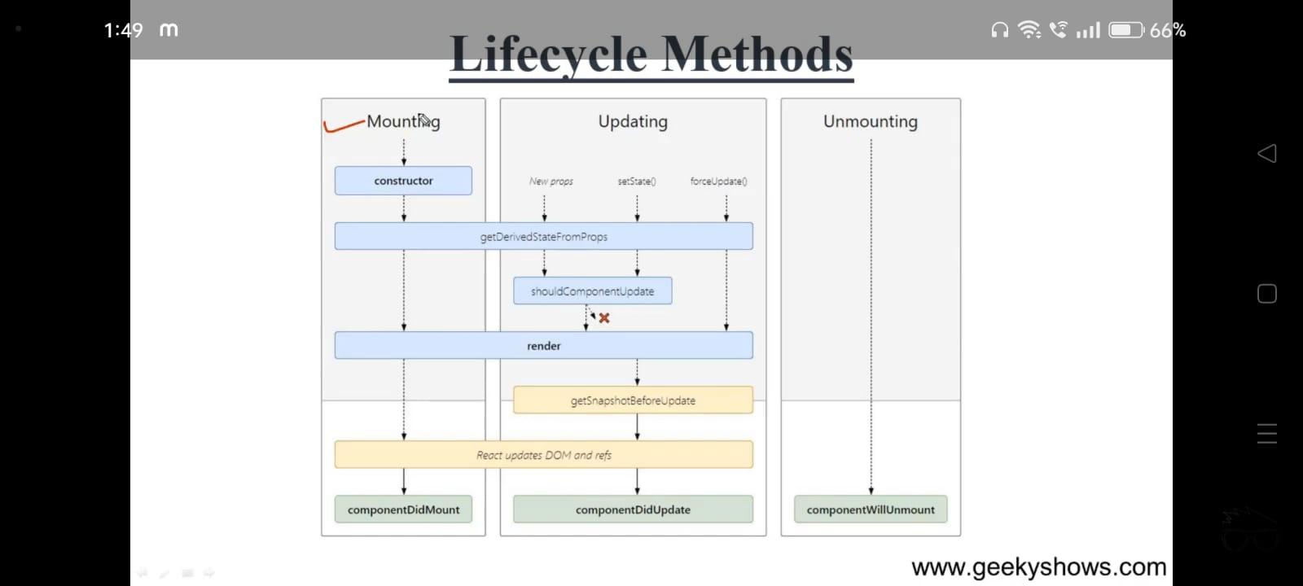

10.1.1. Mounting
Mounting refers to the process of creating and inserting a component into the DOM for the first time in a React application. During mounting, React initializes the component, sets up its internal state (if any), and inserts it into the DOM.
- Constructor:- Method to initialize state and bind methods. Executed before the component is mounted.
constructor(props) {
super(props); // Always call super(props) before using this.props
this.state = {
count: 0, // Initial state
};
console.log("Constructor called");
}
- getDerivedStateFromProps:- Used for updating the state based on props. Executed before every render.
static getDerivedStateFromProps(props, state) {
if (props.value !== state.value) {
return { value: props.value }; // Update state based on new props
}
return null; // No changes to state
}

- render():- Responsible for rendering JSX and updating the DOM.
render() {
return (
<div>
<h1>Hello, React Lifecycle!</h1>
</div>
);
}
- componentDidMount():- This function is invoked right after the component is mounted on the DOM, i.e. this function gets invoked once after the render() function is executed for the first time.
componentDidMount() {
console.log("Component has been mounted");
// Example: Fetch data from an API
fetch("https://api.example.com/data")
.then(response => response.json())
.then(data => this.setState({ data }));
}

10.1.2. Updation
Updating refers to the process of a component being re-rendered due to changes in its state or props. This phase occurs whenever a component's internal state is modified or its parent component passes new props. When an update happens, React re-renders the component to reflect the changes and ensures that the DOM is updated accordingly.
- getDerivedStateFromProps:-
getDerivedStateFromProps(props, state) is a static method that is called just before the render() method in both the mounting and updating phase in React. It takes updated props and the current state as arguments.
static getDerivedStateFromProps(props, state) {
if (props.name !== state.name) {
return { name: props.name }; // Update state with new props
}
return null; // No state change
}
- setState() Function:-
This is not particularly a Lifecycle function and can be invoked explicitly at any instant. This function is used to update the state of a component. You may refer to this article for detailed information.
this.setState((prevState, props) => ({
counter: prevState.count + props.diff
}));
- shouldComponentUpdate():-
It is a lifecycle method in React class components that determines whether a component should re-render. It compares the current and next props/states and returns true if the component should update or false if it should not.
shouldComponentUpdate(nextProps, nextState)

It returns true or false, if false, then render(), componentWillUpdate(), and componentDidUpdate() method does not get invoked.
- getSnapshotBeforeUpdate() Method:-
The getSnapshotBeforeUpdate() method is invoked just before the DOM is being rendered. It is used to store the previous values of the state after the DOM is updated.
getSnapshotBeforeUpdate(prevProps, prevState)
- componentDidUpdate()
Similarly, this function is invoked after the component is rendered, i.e., this function gets invoked once after the render() function is executed after the updation of State or Props.
componentDidUpdate(prevProps, prevState, snapshot)
10.1.3. Unmounting
This is the final phase of the lifecycle of the component, which is the phase of unmounting the component from the DOM. The following function is the sole member of this phase.
- componentWillUnmount()
This function is invoked before the component is finally unmounted from the DOM, i.e., this function gets invoked once before the component is removed from the page, and this denotes the end of the lifecycle.

10.2 What is the need for the react lifecycle?
It provides a structured way to handle specific tasks at various points in a component’s life, such as when it is created, updated, or destroyed.
- Data Fetching: Lifecycle methods like componentDidMount() and componentDidUpdate() allow you to fetch data, subscribe to services, or update external resources at the appropriate time.
- Performance Optimization: By controlling when certain actions occur (e.g., using shouldComponentUpdate() to prevent unnecessary re-renders), you can optimize performance and ensure your app runs efficiently.
- Resource Management: The lifecycle helps with cleanup tasks, such as removing event listeners, canceling network requests, or clearing timers (using methods like componentWillUnmount()) to prevent memory leaks.
- Handling State and Props Changes: The lifecycle provides hooks to update and respond to state & props changes in a controlled way, allowing for dynamic behavior and interaction in your components.
- Handling Component Removal: When a component is no longer needed, the lifecycle helps you clean up resources and ensure that nothing unnecessary continues to run.

10.3 React lifecycle method in class component vs functional component
- In class components:- we need different methods for handling state and side effects, which can be more complex.
- In functional components:- hooks like useState() and useEffect() make it easier to manage state and side effects, making the code shorter and simpler. Functional components are often preferred because they're cleaner and easier to understand.
Features | Class Components | Functional Components
State Initialization | constructor() | useState()
Lifecycle Methods | componentDidMount(), shouldComponentUpdate(), componentDidUpdate(), componentWillUnmount() | useEffect() handles mounting, updating, and unmounting
Handling Updates | shouldComponentUpdate(), componentDidUpdate() | useEffect() with dependency array
Cleanup | componentWillUnmount() | Return cleanup function in useEffect()
Functionality | Component methods tied to lifecycle phases | Hooks like useState, useEffect, useCallback, useMemo

Practical 1:- (inside Class component)
Index.js
import React from "react";
import ReactDOM from 'react-dom';
class Test extends React.Component {
constructor(props) {
super(props);
this.state = { hello: "World!" };
}
componentDidMount() {
console.log("componentDidMount()");
}
changeState() {
this.setState({ hello: "Students!" });
}
render() {
return (
<div>
<h1>
Hello Welcome to React JS
{this.state.hello}
</h1>
<h2>
<a
onClick={this.changeState.bind(
this
)}
>
Press Here!
</a>
</h2>
</div>
);
}
shouldComponentUpdate(nextProps, nextState) {
console.log("shouldComponentUpdate()");
return true;
}
componentDidUpdate() {
console.log("componentDidUpdate()");
}
}
const root = ReactDOM.createRoot(
document.getElementById("root")
);
root.render(<Test />);
Explanation:-
- The Test class is a React component with a state property hello initially set to “World!”.
- The componentDidMount() method runs after the component is added to the DOM, logging “componentDidMount().”
- The changeState() method updates the state to change hello to “Students!” when called.
- In the render() method, the component displays the hello state inside an <h1> tag and includes a link to trigger the changeState() function.
- The shouldComponentUpdate() method logs “shouldComponentUpdate()” and allows the component to re-render while componentDidUpdate() logs “componentDidUpdate()” after the update.
Practical 2:- (Inside Functional component using Hooks)
Index.js
import React, { useEffect } from "react";
function Demo() {
useEffect(() => {
console.log("Component mounted");
return () => {
console.log("Component will unmount");
};
}, []); // empty array = only on mount/unmount
return <h1>Hello with useEffect</h1>;
}
11. React Router
React Router is a standard library for routing in React. It allows the application to navigate between views (pages) without reloading the browser. The current version is v6.

Key Features of React Router:
- Declarative routing with <Route> and <Link> components.
- Dynamic routing based on state or data.
- Supports nested routes and route parameters.
- Browser history integration for forward/back navigation.
- Enables multiple views in a SPA.
- Keeps UI in sync with the URL.
- Easy to implement client-side routing.
11.1 Important Components in React Router v6+
Component/Hook | Purpose
<BrowserRouter> | Top-level wrapper for routing
<Routes> / <Route> | Define path-to-component mapping
<Link> / <NavLink> | Navigation without page reload
useNavigate() | Programmatic navigation
useParams() | Extract route parameters (e.g., :id)
useLocation() | Get current location object

11.1.1. BrowserRouter and HashRouter

BrowserRouter: Uses the HTML5 history API to keep your UI in sync with the URL.

HashRouter: Uses the hash portion of the URL (i.e., window.location.hash) to keep your UI in sync with the URL.
<BrowserRouter>
(/* Your routes go here */}
</BrowserRouter>

11.1.2. Routes and Route

Routes: A container for all your route definitions.

Route: Defines a single route with a path and the component to render.
<Routes>
<Route path="/" element={<Home />} />
<Route path="/about" element={<About />} />
</Routes>

11.1.3. Link and NavLink

Link: Creates navigational links in your application.

NavLink: Similar to Link but provides additional styling attributes when the link is active.

<nav>
<NavLink to="/" activeClassName="active">Home</NavLink>
<Link to="/about">About</Link>
</nav>

11.2 Types of React Routers
There are three type of react routers in React:
- BrowserRouter: The BrowserRouter is the most commonly used router for modern React applications. It uses the HTML5 History API to manage routing, which allows the URL to be dynamically updated while ensuring the browser's address bar and history are in sync.
- HashRouter: The HashRouter is useful when you want to use a URL hash (#) for routing, rather than the HTML5 history API. It doesn't require server configuration and works even if the server doesn't support URL rewriting.
- MemoryRouter: The MemoryRouter is used in non-browser environments, such as in React Native or when running tests.
12. Setting up the React-Router
To add React Router in your application, run this in the terminal from the root directory of the application:
If you are upgrading from v5, you will need to use the @latest flag:
Step 1: Installation
npm i -D react-router-dom@latest

Step 2: Import Required Components
You typically need:
- BrowserRouter (or HashRouter)
- Routes
- Route
- Link or NavLink
Structure:
import { BrowserRouter as Router, Routes,
Route, Link} from 'react-router-dom';

Step 3: Wrap Your App with <BrowserRouter>
import React from 'react';
import { BrowserRouter as Router } from 'react-router-dom';
import App from './App';
const Root = () => (
<Router>
<App />
</Router>
);
export default Root;

Step 4: Create Route Components
Each route should map to a specific component.
function Home() {
return <h2>Home Page</h2>;
}
function About() {
return <h2>About Page</h2>;
}

Step 5: Define Routes in App.js
Use the Routes and Route components to set up the paths.
import { Routes, Route, Link } from 'react-router-dom';
import Home from './Home';
import About from './About';

function App() {
return (
<div>
<nav>
<Link to="/">Home</Link> | <Link to="/about">About</Link>
</nav>
<Routes>
<Route path="/" element={<Home />} />
<Route path="/about" element={<About />} />
</Routes>
</div>
);
}
export default App;
13. Route Component
The <Route> component is used to map a URL path to a React component.
Key Props:
Prop | Description
path | The URL path to match (e.g., /about, /contact)
element | The JSX element (component) to render for that route

<Route path="/about" element={<About />} />

Example:
<Routes>
<Route path="/" element={<Home />} />
<Route path="/about" element={<About />} />
<Route path="/contact" element={<Contact />} />
</Routes>

Note:
- Always use <Routes> as the parent of all <Route> components.
In older versions (v5), the syntax was different:
<Route path="/about" component={About} />
- But in React Router v6, element={<Component />} is used instead.

14) Link and NavLink Components

<Link>
The <Link> component is a declarative, SPA-friendly alternative to the traditional HTML <a> tag. It is provided by the React Router library to enable seamless, client-side navigation between different routes in your React application without triggering a page refresh.

14.1 Key Characteristics of <Link>:Why Not Use <a> Tags?
Feature | Description
Client-side navigation | Changes the URL without reloading the page.
Declarative | You declare routes as components and use <Link> to navigate to them.
Improves performance | Prevents full-page reloads, keeping the app fast and responsive.
Preserves state | Since the page doesn't reload, component states and data are not lost.
History-aware | Works with browser history (back/forward buttons).

14.2 comparison with <a> & <link> tag
HTML <a href=""> reloads the entire page by default, leading to:
- Full page refresh
- Loss of application state
- Slower performance
Instead, <Link> intercepts the navigation and updates the browser’s history using the HTML5 History API, allowing React to render the required component dynamically.

Typical Syntax:
<Link to="/about">About Us</Link>
Here, to="/about" is equivalent to setting href="/about" in an anchor tag, but without reloading the page.

14.3 <NavLink>
The <NavLink> component is a specialized version of <Link> that is used primarily for navigation menus, where you want to visually indicate which link is "active" (i.e., matches the current URL path).

14.4 Key Characteristics of <NavLink>:
Feature | Description
Active styling | Automatically adds a class or style to the link when it matches the current path.
Conditional rendering | You can style or change behavior based on whether the link is active.
Useful in navigation UI | Ideal for menus, tabs, sidebars, or breadcrumbs.
Active styling | Automatically adds a class or style to the link when it matches the current path.

14.5 When to Use NavLink over Link:
Use Case | Recommended Component
Simple page navigation | <Link>
Menus with active states | <NavLink>

14.6 Example with Class Styling:
<NavLink to="/about" className={({ isActive }) => isActive ? "active-link" : ""} >
About
</NavLink>

- The isActive property tells you whether the link matches the current URL.
- You can return a class name or inline styles conditionally.

14.7 NavLink vs Link – Quick Comparison:
Feature | <Link> | <NavLink>
Navigation | Yes | Yes
SPA-friendly | Yes | Yes
Active styling support | No | Yes (isActive, className, style)
Ideal for navigation bar | Not ideal | Recommended

14.7 Behind the Scenes:
- Both <Link> and <NavLink> rely on the same core mechanism under the hood:
- They prevent the browser’s default behavior of full-page reloads.
- They use the React Router context and HTML5 History API to update the URL.
- They re-render only the matching route’s components.
Practical :- Demonstrating entire react -routing process
Dependencies list after installing react router
"dependencies": {
"@testing-library/jest-dom": "^5.17.0",
"@testing-library/react": "^13.4.0",
"@testing-library/user-event": "^13.5.0",
"react": "^18.3.1",
"react-dom": "^18.3.1",
"react-router-dom": "^6.24.1",
"react-scripts": "5.0.1",
"web-vitals": "^2.1.4"
}

Project Structure
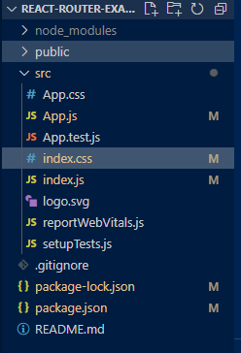
Implementing basic routes in a React App.
index.css
/* src/index.css */
body {
font-family: Arial, sans-serif;
background-color: #f4f4f4;
margin: 0;
padding: 0;
}

h2 {
text-align: center;
color: #333;
}

nav ul {
display: flex;
justify-content: center;
list-style: none;
padding: 0;
}

nav li {
margin: 0 10px;
}

nav a {
text-decoration: none;
color: #333;
}

button {
display: block;
margin: 20px auto;
padding: 10px 20px;
background-color: #007BFF;
color: white;
border: none;
border-radius: 5px;
cursor: pointer;
}
button:hover {
background-color: #0056b3;
}
Index.js
// src/index.js
import React from "react";
import ReactDOM from "react-dom/client";
import "./index.css";
import App from "./App";
const root = ReactDOM.createRoot(document.getElementById('root'));
root.render(
<App />
);

App .js
// src/App.js
import React from "react";
import {
BrowserRouter as Router,
Routes,
Route,
Link,
useNavigate,
Outlet,
} from "react-router-dom";
// Home Page Component
const Home = () => {
const navigate = useNavigate();
return (
<div>
<h2>Home Page</h2>
<button onClick={() =>
navigate("/contact")}>Go to Contact</button>
</div>
);
};
// About Page Component
const About = () => (
<div>
<h2>About Page</h2>
<nav>
<ul>
<li>
<Link to="team">Our Team</Link>
</li>
<li>
<Link to="company">Our Company</Link>
</li>
</ul>
</nav>
<Outlet />
</div>
);
// Components for other pages
const Contact = () => <h2>Contact Page</h2>;
const Team = () => <h2>Team Page</h2>;
const Company = () => <h2>Company Page</h2>;
function App() {
return (
<Router>
<nav>
<ul>
<li>
<Link to="/">Home</Link>
</li>
<li>
<Link to="/about">About</Link>
</li>
<li>
<Link to="/contact">Contact</Link>
</li>
</ul>
</nav>
{/*Implementing Routes for respective Path */}
<Routes>
<Route path="/" element={<Home />} />
<Route path="/about" element={<About />}>
<Route path="team" element={<Team />} />
<Route path="company" element={<Company />} />
</Route>
<Route path="/contact" element={<Contact />} />
</Routes>
</Router>
);
}
export default App;
Run the application using the following command.
command:- npm start
15. State Management with Context API
The React Context API is a powerful tool for efficient state management, offering a cleaner alternative to prop drilling and enhancing overall code organization.
Context API is built into React and is used for dependency injection—meaning it allows a parent component to pass data to deeply nested child components without prop drilling.
Example: Suppose you have a theme switcher in your app. Instead of passing the theme as a prop through multiple components, you can store it in a Context and access it anywhere in the component tree.
15.1 When to Use Context API ?
- Small to medium apps where prop drilling is the only concern.
- Simple state-sharing like themes, authentication, or language settings.
- Don’t want to install an external library like Redux.
As we know that we use context-API in order to prevent Prop-Drilling so lets understand what is prop-Drilling?
15.2 Problem Prop-Drilling?
Prop Drilling is a common mistake beginners make while building React apps. It can cause reduced code readability and even performance issues for the app.
Prop Drilling is the process of passing data(props) from a parent component to a deeply nested child component in a React application. This process involves passing data through multiple intermediary components to reach the final child component. The intermediary components may not use this data, and may only serve the duty of passing to the child component. Although this is a straightforward approach, it can make the codebase harder to maintain and scale. For example, changes in the data structure or components may require updates in all intermediate levels.

Example

Imagine a scenario, where we have three components, App Component, Body Component and Greeting Component.

Body Component is the child of App Component and the Greeting Component is the child of the Body Component.
Step 1:- The "App" component passes the "username" prop to its child, "BodyComponent".
App.js
const App = () => {
return <BodyComponent username="Farhan" />;
};
Step 2:- The "BodyComponent" receives the "username" prop and passes it down to the "GreetingComponent". Note that, "BodyComponent" is not using this prop for itself.
BodyComponent.js
const BodyComponent = (props) => {
return <GreetingComponent username={props.username} />;
};
Step 3:- Finally, GreetingComponent displays the name with the greeting.
GreetingComponent.js
const GreetingComponent = (props) => {
return <h4>Hello, {props.username}!</h4>;
};
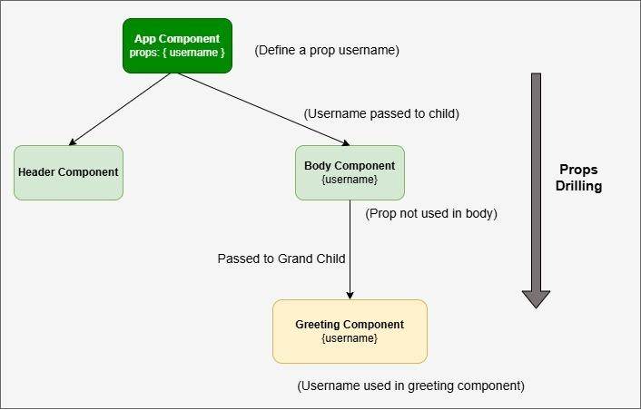

15.3 Why Prop Drilling is Problematic?
Prop drilling is problematic because:
- Code Complexity: It makes the component tree overly complicated, as intermediate components receive and forward props without using them, cluttering your code and causing confusion.
- Maintenance Overhead: Any change to the props requires updating multiple components, which can be time-consuming and error-prone.
- Reduced Readability: It becomes difficult to trace how and where data flows through components, making debugging and development more challenging.
- Tight Component Coupling: Components become less reusable and more tightly coupled, leading to reduced flexibility and difficulties in refactoring.
- Scalability Issues: As your application grows, prop drilling worsens, leading to further complexity and making the app harder to scale effectively.

15.4 How to Avoid Prop Drilling Problem?
prop-drilling can be avoided using following approaches
- context API

Global State Management (Redux, Zustand, MobX)
- Custom-Hooks
Let's first understand the practical use-case with context API. Other approaches will be covered in further topics.
15.5 How Context API works?
Step 1: Creating a Context
The process begins by creating a context using the createContext() method.
const MyContext = React.createContext();
Step 2: Providing the Context
The Provider component is used to wrap parts of your app and provide data to all components inside it.
// Providing the context value
function MyApp() {
return (
<MyContext.Provider value={/* your shared value */}>
{/* Components that can access the context value */}
</MyContext.Provider>
); }
Step 3: Consuming the Context:- The Consumer component is used to consume the context data in a child component.
function AnotherComponent() {
const contextValue = React.useContext(MyContext);
// Now, contextValue contains the shared value
}

16. Practical:- Project-ToDo list
Mini project-ToDo list (showcasing all context,provider, consumer)
step 1:- create a react-app:- create react-app using following command:-
npx create-react-app todo-list-context
step 2:- navigate to the root directory
cd todo-list-context
project structure:-
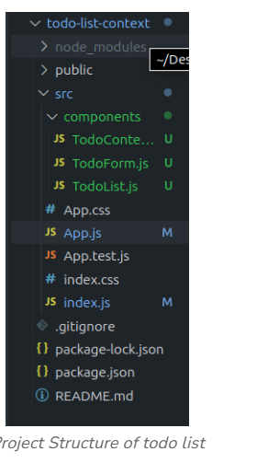

package.json
"dependencies": {
"@testing-library/jest-dom": "^5.17.0",
"@testing-library/react": "^13.4.0",
"@testing-library/user-event": "^13.5.0",
"react": "^18.2.0",
"react-dom": "^18.2.0",
"react-scripts": "5.0.1",
"redux": "^5.0.1",
"web-vitals": "^2.1.4"
}
- In your src/index.js, wrap your App component with the TodoProvider.
- Now src/components/TodoForm.js , let's create components to interact with the to-do list.
- Now its turn for src/components/TodoList.js
- Now, in your src/App.js, use the TodoForm and TodoList components.
1. TodoContext.js
import React, { createContext, useState }
from 'react';
const TodoContext = createContext();
const TodoProvider = ({ children }) => {
const [todos, setTodos] = useState([]);
const addTodo = (text) => {
setTodos([...todos, { text, id: Date.now() }]);
};
const removeTodo = (id) => {
setTodos(todos.filter((todo) => todo.id !== id));
};
return (
<TodoContext.Provider value={{
todos,
addTodo, removeTodo
}}>
{children}
</TodoContext.Provider>
);
};
export { TodoProvider, TodoContext };

2. index.js
import ReactDOM from 'react-dom/client';
import App from './App';
import { TodoProvider } from './TodoContext';
const root = ReactDOM.createRoot(document.getElementById('root'));
root.render(
<TodoProvider>
<App />
</TodoProvider>
);

3. TodoForm.js
import React, { useState, useContext } from 'react';
import { TodoContext } from './TodoContext';
const TodoForm = () => {
const { addTodo } = useContext(TodoContext);
const [text, setText] = useState('');
const handleSubmit = (e) => {
e.preventDefault();
addTodo(text);
setText('');
};
return (
<form onSubmit={handleSubmit}>
<input
type="text"
value={text}
onChange={(e) => setText(e.target.value)}
placeholder="Add a new todo"
/>
<button type="submit">Add Todo</button>
</form>
);
};
export default TodoForm;

- TodoList.js
import React, { useContext } from 'react';
import { TodoContext } from './TodoContext';
const TodoList = () => {
const { todos, removeTodo } = useContext(TodoContext);
return (
<ul>
{todos.map((todo) => (
<li key={todo.id}>
{todo.text}
<button onClick={() =>
removeTodo(todo.id)}>Remove</button>
</li>
))}
</ul>
);
};
export default TodoList;
- App.js
import React from 'react';
import TodoForm from './TodoForm';
import TodoList from './TodoList';
const App = () => {
return (
<div>
<h1>My Todo List</h1>
<TodoForm />
<TodoList />
</div>
);
};
export default App;
now run the application using command
npm start

output:-
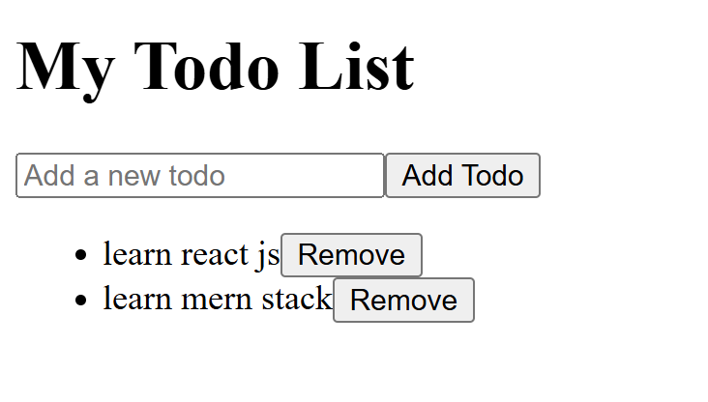

17. React Hooks
Hooks allow us to "hook" into React features such as state and lifecycle methods.Hooks were added to React in version 16.8.
Hooks allow function components to have access to state and other React features. Because of this, class components are generally no longer needed.
Although Hooks generally replace class components, there are no plans to remove classes from React.

17.1 Hook Rules
There are 3 rules for hooks:
- Hooks can only be called inside React function components.
- only call Hooks at the top-level :- we should not call Hooks inside loops, conditions, or nested functions. instead always use Hooks at the top level of your React functions.
- Only call Hooks from React functions- we should not call Hooks from regular JS functions. Instead call Hooks from React function components or call Hooks from custom hooks.
- Hooks don’t work inside classes.

17.2 Why the need for ReactJs Hooks?
Here’s why ReactJS Hooks are needed:
- Simplifies State Management: Hooks allow easier state management in functional components without the need for class components.
- Eliminates 'this' Keyword: The complexity of managing this in class components is avoided, making the code cleaner.
- Reusable Logic: Hooks enable sharing stateful logic across components without changing component hierarchies.
- Improved Code Structure: Code becomes more modular and easier to maintain by using hooks to manage different concerns.
- Cleaner Code: Functional components with hooks are more concise, reducing boilerplate code compared to class components.
- Better Developer Experience: Hot reloading works better with hooks, improving the overall developer workflow.
17.3 Types of React Hooks
- State Hook
- Context Hook
- Effect Hook:- useEffect, useLayoutEffect,useInsertionEffect

Performance Hook:- useMemo,useCallback

Resource Hooks:- useFetch

Other Hooks:- useReducer,useImperativeHandle,useLawetEffect
- Custom Hooks

18. useState Hook
The React useState Hook allows us to track state in a function component.
State generally refers to data or properties that need to be tracked in an application.Without useState, functional components were "stateless" and could not respond to user actions or time-based changes.

18.1 What is the State in the React?
State refers to data or values that a component maintains and responds to during its lifecycle. For example:
- The number in a counter
- The value typed in an input field
- A toggle on/off state
- Fetched API data
When state changes, React re-renders the component, updating the UI with the latest values.
18.2 useState Syntax:-
const [state, setState] = useState(initialValue);
Part | Description
state | The current value of the state
setState | A function that updates the state and re-renders
initialValue | The default value assigned to the state
18.3 Types of Initial Values
Data Type | Example
String | useState("Hello")
Number | useState(0)
Boolean | useState(true)
Object | useState({ name: "", age: 0 })

18.4 How Does useState() Work?
The useState() hook allows you to add state to functional components in React. It works by:
1. Initialize State: When you call useState(initialValue), it creates a state variable and an updater function.
const [count, setCount] = useState(0);
2. State is Preserved Across Renders: React remembers the state value between re-renders of the component. Each time the component renders, React keeps the latest value of count.
3. State Updates with the Updater Function: When you call setCount(newValue) React updates the state and it re-renders the component to reflect the new state value.
<button onClick={() => setCount(count + 1)}>Increment</button>
4. Triggers Re-render: React will re-render only the component where useState was used—ensuring your UI updates automatically when the state changes.
18.5 Practical 1: Counter App
Index.js
import ReactDOM from 'react-dom/client';
import Counter from './App';
const root = ReactDOM.createRoot(document.getElementById('root'));
root.render(
<Counter />
);
App.js
import React, { useState } from 'react';
const Counter = () => {
const [count, setCount] = useState(0);
return (
<div>
<h2>Count: {count}</h2>
<button onClick={() => setCount(count + 1)}>Increment</button>
<button onClick={() => setCount(0)}>Reset</button>
</div>
);
};
export default Counter;
Output:-
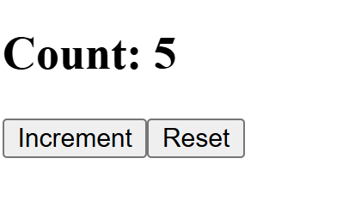
18.6 Practical 2: Toggle Password Visibility
App.js
import React, { useState } from 'react';
const PasswordToggle = () => {
const [visible, setVisible] = useState(false);
return (
<div>
<input type={visible ? 'text' : 'password'} />
<button onClick={() => setVisible(!visible)}>
{visible ? 'Hide' : 'Show'} Password
</button>
</div>
);
};
export default PasswordToggle;
Output:-
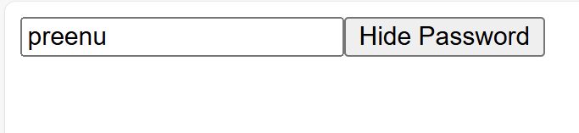

18.7 Best Practices with useState
- Use multiple useState calls for unrelated state values.
- Use functional updates when relying on previous state:
setCount(prev => prev + 1);
- Do not directly mutate the state (e.g., count++).
- When working with arrays/objects, always create a new copy using spread operator.
19. useEffect hook
The useEffect Hook allows you to perform side effects in your components.Before hooks, these kinds of tasks were only possible in class components through lifecycle methods like componentDidMount, componentDidUpdate, and componentWillUnmount.
This hook runs on every render but there is also a way of using a dependency array using which we can control the effect of rendering. It can be used to perform actions such as:
- Fetching data from an API.
- Setting up event listeners or subscriptions.
- Manipulating the DOM directly (although React generally handles DOM manipulation for you).
- Cleaning up resources when a component unmounts.
Some examples of side effects are: fetching data, directly updating the DOM, and timers.
19.1 Syntax:-
useEffect(() => {
// side-effect logic here
return () => {
// optional cleanup
};
}, [dependencies]);
19.2 How does it work?
- Initial Render Happens: React renders the component and updates the DOM.
- useEffect Executes After Render: It runs after the paint, not during render.
- Dependencies Are Checked: If there is no dependency array, the effect runs after every render; if the array is empty ([]), it runs once on mount; if dependencies are provided, it runs only when those values change.
- Cleanup Function Runs: Before the effect re-runs or the component unmounts, the cleanup function (returned from useEffect) is executed.
- Effect Re-runs: If dependencies changed, the effect runs again — after cleanup.
19.3 When Does useEffect() Run?
Dependency Array | Behavior
No array (default) | Runs after every render (including re-renders)
Empty array [] | Runs only once after initial render (like componentDidMount)
[var1, var2] | Runs when any dependency changes

19.4 Practical 1: Fetching Data from an API on Mount
App.js
import React, { useEffect, useState } from 'react';
const UserList = () => {
const [users, setUsers] = useState([]);
useEffect(() => {
// fetch data from API
fetch('https://jsonplaceholder.typicode.com/users')
.then(res => res.json())
.then(data => setUsers(data));
}, []); // runs only once on mount
return (
<div>
<h2>User List</h2>
<ul>
{users.map(user => <li key={user.id}>{user.name}</li>)}
</ul>
</div>
);
};
export default UserList;
output:-
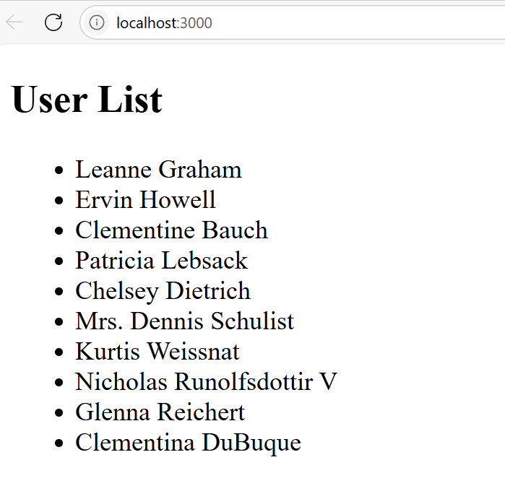

Practical 2:- Updating the Page Title on State Change
App.js
import React, { useState, useEffect } from 'react';
const TitleUpdater = () => {
const [count, setCount] = useState(0);
useEffect(() => {
document.title = `Clicked ${count} times`;
}, [count]); // runs every time count changes
return (
<button onClick={() => setCount(count + 1)}>
Click me ({count})
</button>
); };
export default TitleUpdater;
Output:-
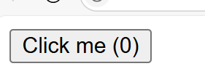

Practical 3:- Window Resize Event Listener
import React, { useState, useEffect } from 'react';
const WindowSize = () => {
const [width, setWidth] = useState(window.innerWidth);
useEffect(() => {
const handleResize = () => setWidth(window.innerWidth);
window.addEventListener('resize', handleResize);
// Cleanup
return () => window.removeEventListener('resize', handleResize);
}, []);
return <h3>Window Width: {width}px</h3>;
};
export default WindowSize;

Output:-
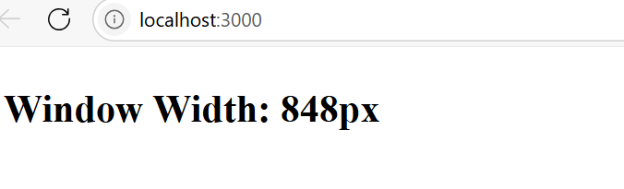
When window size shrinks
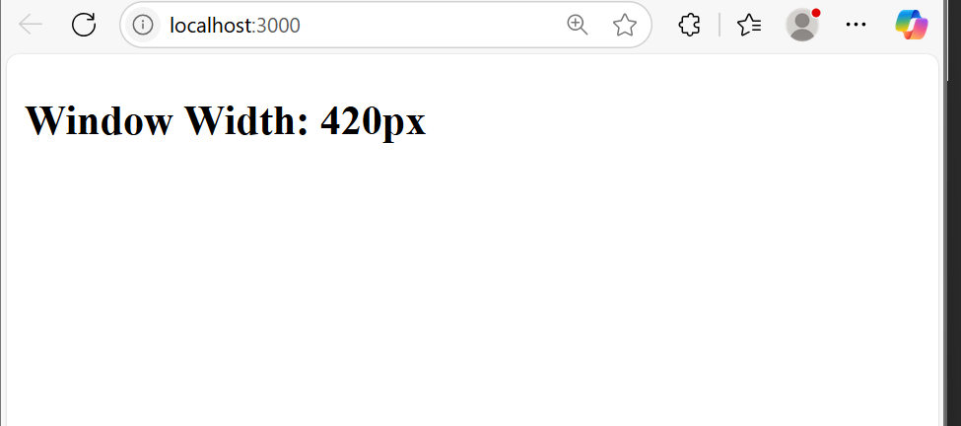

20.Using useContext Hook
React Context is a way to manage state globally.It can be used together with the useState Hook to share state between deeply nested components more easily than with useState alone.
In order to use the Context in a child component, we need to access it using the useContext Hook.
First, include the useContext in the import statement:
import { useState, createContext, useContext } from "react";
Syntax:-
const value = useContext(MyContext);
- You provide context using MyContext.Provider
- You consume it using useContext(MyContext)

20.1 Real-World Use Cases for useContext
Use Case | Context Value Examples
User Authentication | user, login(), logout()
Theme Switching | theme, toggleTheme()
Language (i18n) | language, changeLanguage()
Global App Settings | config, appName, apiUrl
Shopping Cart | cartItems,addToCart(), totalPrice

20.2 Practical:-
ThemeContext.js
import { createContext } from 'react';
export const ThemeContext = createContext();
ThemeProvider.js
import React, { useState } from 'react';
import { ThemeContext } from './ThemeContext';
const ThemeProvider = ({ children }) => {
const [theme, setTheme] = useState('light');

const toggleTheme = () => setTheme(prev => (prev === 'light' ? 'dark' : 'light'));
return (
<ThemeContext.Provider value={{ theme, toggleTheme }}>
{children}
</ThemeContext.Provider>
);
};
export default ThemeProvider;
App.js
import React from 'react';
import ThemeProvider from './ThemeProvider';
import Header from './Header';
const App = () => {
return (
<ThemeProvider>
<Header />
<p>This is the main content.</p>
</ThemeProvider>
);
};
export default App;
Header.js
import React, { useContext } from 'react';
import { ThemeContext } from './ThemeContext';
const Header = () => {
const { theme, toggleTheme } = useContext(ThemeContext);
return (
<header style={{
background: theme === 'light' ? '#f4f4f4' : '#222',
color: theme === 'light' ? '#000' : '#fff',
padding: '1rem'
}}>
<h1>My Website</h1>
<button onClick={toggleTheme}>Switch to {theme === 'light' ? 'Dark' : 'Light'} Mode</button>
</header>
);
};
export default Header;
Output:-
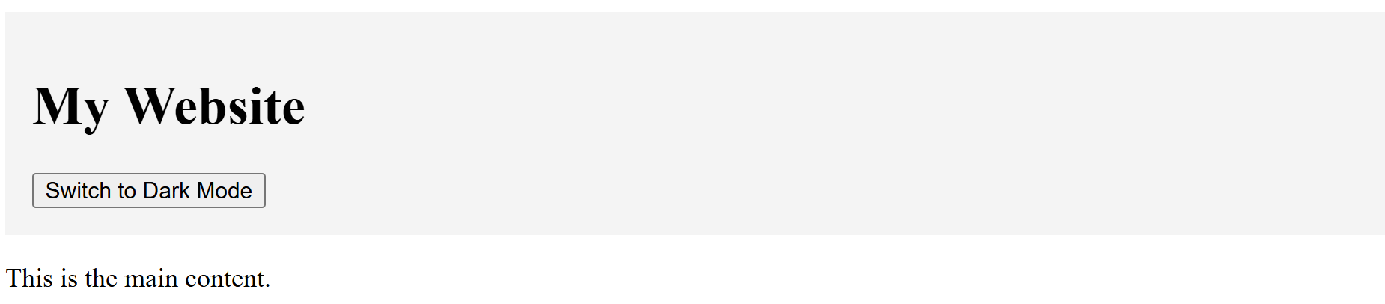



20.3 Best Practices
- Always wrap your consuming components inside the Provider
- Keep context values clean and organized (group data/functions)
- Use custom hooks for large contexts to simplify usage
- Avoid using context for high-frequency updates (like keystrokes)

21. Creating Custom Hooks
React’s custom hooks let you extract reusable logic from components and organize it in a clean, functional way. A custom hook is simply a JavaScript function that starts with use and may call other hooks inside it (useState, useEffect, etc.).
When you have component logic that needs to be used by multiple components, we can extract that logic to a custom Hook.

Syntax:-
function useCustomHook() {
// Use built-in hooks here
return someValue;
}
21.1 Practical 1:- storing data in localstorage
App.js
import React from 'react';
import useLocalStorage from './useLocalStorage';
const App = () => {
const [name, setName] = useLocalStorage('username', '');

return (
<div>
<input value={name} onChange={e => setName(e.target.value)} />
<p>Hello, {name}!</p>
</div>
);
};
export default App;

useLocalStorage.js
import { useState } from 'react';
function useLocalStorage(key, initialValue) {
const [storedValue, setStoredValue] = useState(() => {
const saved = localStorage.getItem(key);
return saved ? JSON.parse(saved) : initialValue;
});
const setValue = (value) => {
setStoredValue(value);
localStorage.setItem(key, JSON.stringify(value));
};
return [storedValue, setValue];
}
export default useLocalStorage;
Output:-
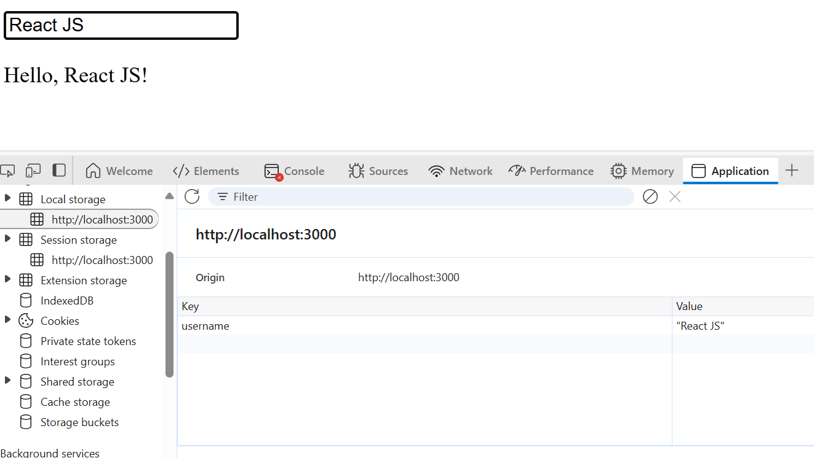
Practical 2:- Fetching Data by creating the custom hook
App.js
import { useState, useEffect } from 'react';
function useFetch(url) {
const [data, setData] = useState(null);
const [loading, setLoading] = useState(true);
useEffect(() => {
fetch(url)
.then((response) => response.json())
.then((data) => {
setData(data);
setLoading(false);
});
}, [url]);
return { data, loading };
}
function DataComponent() {
const { data, loading } = useFetch("https://jsonplaceholder.typicode.com/todos/1");
return (
<div>
{loading ? <p>Loading...</p> : <p>Data: {JSON.stringify(data)}</p>}
</div>
);
}
export default DataComponent;
Output:-
You will be having the API data on the screen
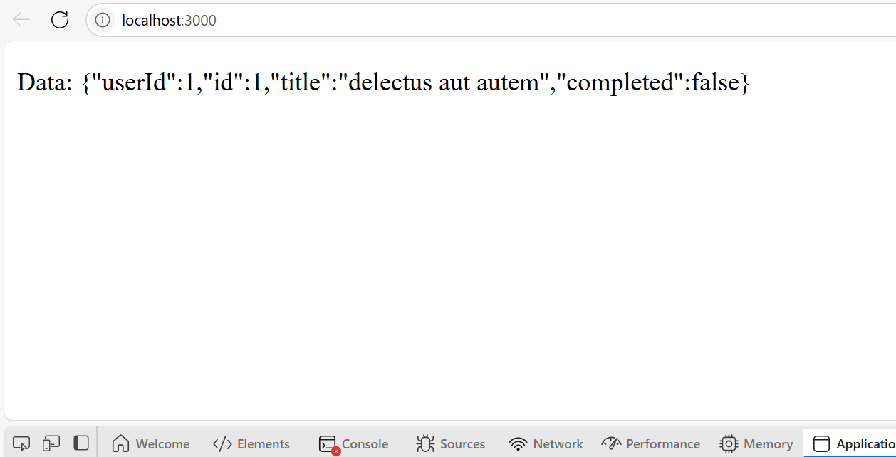
21.2 Best Practices
- Always prefix with use → useMyHook
- Keep logic generic and reusable.
- Add prop validation and error handling where needed.
- Avoid using hooks conditionally inside the custom hook.
- Do not call hooks inside loops or conditionals.

22. Redux for State Management
Redux is a predictable state container for JavaScript applications (especially React). It helps you manage and centralize application state.
Redux is based on a unidirectional data flow:
Action → Reducer → Store → UI
Think of Redux as a global state manager — instead of lifting state up through props, Redux provides a central “store” accessible to any component.It is used with a library like React.
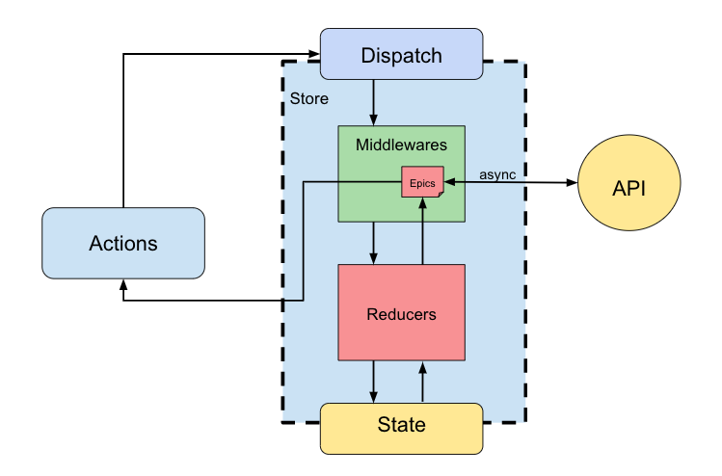
Uses:- It makes it easier to manage state and data. As the complexity of our application increases. At the start, it is hard to understand but it helps to build complex applications. In the beginning, it feels like a lot of work, but it is really helpful. You need:
- redux – the core library for state management.
- react-redux – to bind Redux with React components

22.1 Installation Steps

1. Install Redux & React-Redux
Use npm: npm install redux react-redux

Or yarn: yarn add redux react-redux

Now your project can use Redux concepts like createStore, Provider, useSelector, and useDispatch.

2. (Optional) Install Redux DevTools
For browser debugging:
npm install redux-devtools-extension

22.2 The 3 Core Principles of Redux
Principle | Description
Single Source of Truth | All state is stored in a single store (a plain JS object).
State is Read-Only | The only way to change state is to dispatch an action.
Changes via Pure Functions | Changes are handled by pure functions called reducers.
22.3 Advantages
The advantages to react redux are given below:
- Centralized state management system i.e. Store: React state is stored locally within a component. To share this state with other components in the application, props are passed to child components, or callbacks are used for parent components. Redux state, on the other hand, is stored globally in the store. All the components of the entire application can easily access the data directly. This centralizes all data and makes it very easy for a component to get the state it requires. So while developing large, complex applications with many components, the Redux store is highly preferred.
- Performance Optimizations: By default, whenever a component is updated, React re-renders all the components inside that part of the component tree. In such a case when the data for a given component hasn’t changed, these re-renders are wasted (cause the UI output displayed on the screen would remain the same). Redux store helps in improving the performance by skipping such unnecessary re-renders and ensuring that a given component re-renders only when its data has actually changed.
- Pure reducer functions: A pure function is defined as any function that doesn’t alter input data, doesn’t depend on the external state, and can consistently provide the same output for the same input. As opposed to React, Redux depends on such pure functions. It takes a given state (object) and passes it to each reducer in a loop. In case of any data changes, a new object is returned from the reducer (re-rendering takes place). However, the old object is returned if there are no changes (no re-rendering).
- Storing long-term data: Since data stored in redux persists until page refresh, it is widely used to store long-term data that is required while the user navigates the application, such as data loaded from an API, data submitted through a form, etc. On the other hand, React is suitable for storing short-term data that is likely to change quickly (form inputs, toggles, etc.)
- Great supportive community Since redux has a large community of users, it becomes easier to learn about best practices, get help when stuck, and reuse your knowledge across different applications. Also, there are a number of extensions for redux that help in simplifying the code logic and improving the performance.
23. Redux core concepts:-
Concept | Description
Action | Object that tells Redux what to do
Reducer | Pure function to update state
Store | Central state container
Dispatch | Sends action to reducer
Provider | Makes the store available to React components
useSelector | Reads data from the store
useDispatch | Sends actions to store

We have a single store to manage the whole state of the application. Also, the action method to make necessary changes, we want to do. Reducers are like safety guards that know how to mutate state based on the requested action. And at least middleware is used to handle the task performed in the application.
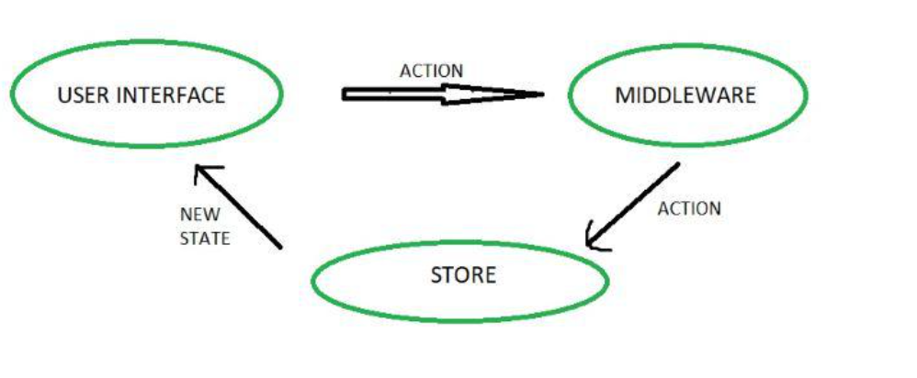
23.1 STORE:
The entire state of an application is listed at a place called Store. It acts as a brain and manages the status of the application. It also has a dispatch(action) function.
23.2 ACTION:
An action is a pure object which is sent or dispatched from the view. It is created to store information about the user’s event such as info about the type of action, the time of occurrence, the location of occurrence, info about its coordinates, and info about the state it aims to change.
23.3 REDUCER:
Reducer is a pure function which is used to return a new state from the initial state. It reads the payloads from the actions. The reducer then updates the store via the state accordingly.

24. Redux Pure Functions
A pure function is a function that:
- Always returns the same output for the same input.
- Has no side effects (no API calls, no modifying external variables, no randomness).
- Pure functions make state changes predictable, traceable, and testable.

24.1 Pure Function Example:
Below is an example of a pure function:
const multiply= (x, y) => x * y;
multiply(5,3);
24.2 Why Are Pure Functions Important in Redux?
Redux relies heavily on reducers, which must be pure functions
- Take current state and an action
- Return new state without changing original state
Shouldn’t perform:
- API calls
- Random number generation
- Modifications to global variables

24.3 Reducer as a Pure Function —
Correct Example
const initialState = { count: 0 };

function counterReducer(state = initialState, action) {
switch (action.type) {
case "INCREMENT":
return { ...state, count: state.count + 1 }; // returns new state
case "DECREMENT":
return { ...state, count: state.count - 1 };
default:
return state;
}
}
Wrong Example (Not Pure)
function badReducer(state, action) {
switch (action.type) {
case "INCREMENT":
state.count++; // mutates the original state
return state;
default:
return state;
}
}

25. Redux Actions
In Redux, an action is a plain JavaScript object that describes an event or an intention to change state.
Think of an action as a messenger — it tells Redux what happened but not how to handle it.
25.1 Basic Structure & Properties of an Action
- type: (Required) A string that describes the action.
- payload: (Optional) Any additional data needed to perform the update.
{
type: 'ADD_TODO',
payload: {
id: 1,
text: 'Learn Redux'
}
}
25.2 Example: Counter Actions
action.js
export const increment = () => {
return {
type: 'INCREMENT'
};
};
export const decrement = () => {
return {
type: 'DECREMENT'
}; };
counter.js
import React from 'react';
import { useDispatch, useSelector } from 'react-redux';
import { increment, decrement } from './redux/actions';
const Counter = () => {
const count = useSelector(state => state.count);
const dispatch = useDispatch();
return (
<div>
<h2>{count}</h2>
<button onClick={() => dispatch(increment())}>+</button>
<button onClick={() => dispatch(decrement())}>-</button>
</div>
);
};
export default Counter;
26. Redux Reducers
In Redux, a reducer is a pure function that:
- Takes the current state and an action as input
- Returns a new updated state
It doesn’t modify the original state — it creates and returns a copy.
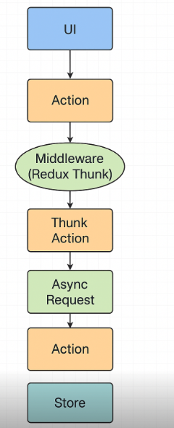

26.1 Key Rules for Reducers

Rule | Why It’s Important
Must be a pure function | To ensure predictability
Should not mutate state | Always return a new copy
Must return default state | When called with undefined
Should use switch/case or if/else | For action handling

Example:- reducers.js
const initialState = { count: 0 };
export function counterReducer(state = initialState, action) {
switch (action.type) {
case 'INCREMENT':
return { ...state, count: state.count + 1 };
case 'DECREMENT':
return { ...state, count: state.count - 1 };
default:
return state;
}
}
Store.js
import { createStore } from 'redux';
import { counterReducer } from './reducers';
const store = createStore(counterReducer);
export default store;
index.js
import React from 'react';
import ReactDOM from 'react-dom';
import { Provider } from 'react-redux';
import store from './redux/store';
import App from './App';

ReactDOM.render(
<Provider store={store}>
<App />
</Provider>,
document.getElementById('root')
);

27. Redux Store
The Redux store is the central place where your app’s global state lives.
It holds the complete state tree of your application.
Think of it as a single source of truth — the store is where all the app data lives and gets updated based on dispatched actions.

27.1 Responsibilities of the Store
- Holds application state
- Allows access to state via getState()
- Allows state to be updated via dispatch(action)
- Registers listeners via subscribe()
- Handles state updates via reducer
27.2 creating a Store
import { createStore } from 'redux';
import rootReducer from './reducers';
const store = createStore(rootReducer);
27.3 Mini project Counter App with Redux
src/
│
├── redux/
│ ├── actions.js
│ ├── reducers.js
│ └── store.js
│
├── App.js
├── index.js
redux/actions.js
export const increment = () => {
return { type: "INCREMENT" };
};
export const decrement = () => {
return { type: "DECREMENT" };
};
redux/reducers.js
const initialState = {
count: 0
};
const counterReducer = (state = initialState, action) => {
switch (action.type) {
case "INCREMENT":
return { ...state, count: state.count + 1 };
case "DECREMENT":
return { ...state, count: state.count - 1 };
default:
return state;
}
};
export default counterReducer;
redux/store.js
import { createStore } from "redux";
import counterReducer from "./reducers";
const store = createStore(counterReducer);
export default store;
App.js
import React from "react";
import { useSelector, useDispatch } from "react-redux";
import { increment, decrement } from "./redux/actions";
function App() {
const count = useSelector(state => state.count);
const dispatch = useDispatch();
return (
<div style={{ textAlign: "center", marginTop: "100px" }}>
<h1>Redux Counter App</h1>
<h2>Count: {count}</h2>
<button onClick={() => dispatch(increment())} style={{ marginRight: 10 }}>
Increment
</button>
<button onClick={() => dispatch(decrement())}>
Decrement
</button>
</div>
);
}
export default App;
index.js
import React from "react";
import ReactDOM from "react-dom";
import { Provider } from "react-redux";
import store from "./redux/store";
import App from "./App";

ReactDOM.render(
<Provider store={store}>
<App />
</Provider>,
document.getElementById("root")
);
27.4 How It Works
Part | Role
actions.js | Defines events that describe what should happen
reducers.js | Describes how state should change
store.js | Holds the app's global state using Redux
index.js | Makes the store accessible to all components using <Provider>
App.js | Uses useSelector to read data and useDispatch to send actions

28. Redux Middleware
Middleware is a function that sits between dispatching an action and the moment it reaches the reducer.It lets you handle side effects like:
- Async API calls
- Logging
- Analytics
- Conditional dispatching
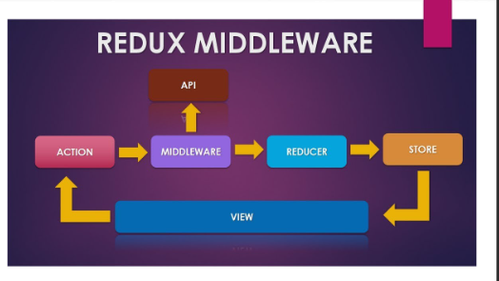

28.1 Why Use redux-thunk?
By default, Redux can only dispatch plain objects.But real apps need to:
- Fetch data from APIs
- Wait before dispatching
redux-thunk lets you dispatch functions (thunks) instead of just objects.
28.2 Steps to set-up
step 1:- install
npm install redux-thunk
step 2:- Create Async Actions
redux/actions.js
export const fetchDataRequest = () => {
return { type: "FETCH_DATA_REQUEST" };
};
export const fetchDataSuccess = (data) => {
return {
type: "FETCH_DATA_SUCCESS",
payload: data
};
};
export const fetchDataFailure = (error) => {
return {
type: "FETCH_DATA_FAILURE",
payload: error
};
};
// Thunk action to fetch data
export const fetchData = () => {
return (dispatch) => {
dispatch(fetchDataRequest());

fetch("https://jsonplaceholder.typicode.com/posts")
.then((res) => res.json())
.then((data) => {
dispatch(fetchDataSuccess(data.slice(0, 5))); // limiting to 5 items
})
.catch((err) => {
dispatch(fetchDataFailure(err.message));
});
};
};

step 3:- Update Reducer
redux/reducers.js
const initialState = {
loading: false,
data: [],
error: ""
};
const dataReducer = (state = initialState, action) => {
switch (action.type) {
case "FETCH_DATA_REQUEST":
return { ...state, loading: true };
case "FETCH_DATA_SUCCESS":
return { loading: false, data: action.payload, error: "" };
case "FETCH_DATA_FAILURE":
return { loading: false, data: [], error: action.payload };
default:
return state;
}
};
export default dataReducer;
Step 5:- Create Store with Middleware
redux/store.js
import { legacy_createStore as createStore, applyMiddleware } from "redux";
import thunk from "redux-thunk";
import dataReducer from "./reducers";
const store = createStore(dataReducer, applyMiddleware(thunk));
export default store;
Step 6:- Use it in React Component
App.js
import React, { useEffect } from "react";
import { useDispatch, useSelector } from "react-redux";
import { fetchData } from "./redux/actions";
function App() {
const dispatch = useDispatch();
const { loading, data, error } = useSelector((state) => state);

useEffect(() => {
dispatch(fetchData());
}, [dispatch]);
return (
<div style={{ padding: 20 }}>
<h1>Async Redux Fetch Example</h1>
{loading && <p>Loading...</p>}
{error && <p style={{ color: "red" }}>{error}</p>}
<ul>
{data.map((item) => (
<li key={item.id}>
<b>{item.title}</b>
</li>
))}
</ul>
</div>
);
}
export default App;

Step 7:- Wrap App with <Provider>
index.js
import React from "react";
import ReactDOM from "react-dom";
import { Provider } from "react-redux";
import App from "./App";
import store from "./redux/store";

ReactDOM.render(
<Provider store={store}>
<App />
</Provider>,
document.getElementById("root")
);

